Final Project
Task Reminder
Course Code: CPE201L | Program: BSCPE
Course Title: Data Structure and Algorithm | Date Performed: November 4, 2025
Section: 2A | Date Submitted: November 8, 2025
Leader: Sumel, Hendrix Nathan L.  Members:  Laput, Mark Danielle E. | Instructor: Engr. Maria Rizette Sayo
1. Objective(s):
Main Objective
Implement a Linked List data structure as the core of a task management application.
Specifically our Objectives is to:
- Design and implement custom Linked List and Node classes
- Build tkinter GUI that interacts directly with the linked list
- Create priority-based visualization using list traversal
- Develop background thread to monitor tasks via list traversal
- Integrate sound notifications for due tasks found during traversal
- Implement JSON persistence for saving/loading the linked list

2. Intended Learning Outcomes (ILOs):
Technical Skills:
- Design and implement complex GUI applications using tkinter
- Create custom dialog windows and modal interfaces
- Implement multi-threading for background processes
- Handle file I/O operations with JSON data serialization
- Integrate multimedia elements (sound) into applications
- Develop date/time manipulation and comparison logic

Programming Concepts:
- Apply Object-Oriented Programming principles
- Implement event-driven programming patterns
- Handle exceptions and error scenarios
- Manage application state and data persistence
- Create responsive and user-friendly interfaces

Problem-Solving Skills:
- Design algorithms for time-based task monitoring
- Implement efficient data structures for task management
- Debug multi-threaded applications
- Optimize GUI performance with canvas and scrollable interfaces

3. Discussion:
GUI Development:
- Tkinter widget hierarchy and layout management
- Custom dialog creation (CalendarDialog, TimeDialog)
- Canvas-based scrollable interfaces
- Color schemes and visual design principles
- Modal vs modeless dialog handling

The application demonstrates sophisticated GUI design principles through its use of tkinter. The interface employs a modern dark theme with carefully chosen color psychology - using red for high priority, blue for medium, and green for low priority tasks, which intuitively communicates importance levels to users. The custom calendar and time dialogs showcase how to extend basic tkinter capabilities to create professional-looking components that enhance user experience. The scrollable canvas implementation for the task list illustrates handling dynamic content that exceeds screen space, a common requirement in real-world applications.

Data Management:
- JSON serialization/deserialization techniques
- File I/O operations with error handling
- Data structure design for task tracking
- State management and data synchronization

This application provides an excellent case study in practical data persistence. By using JSON files for storage, it demonstrates how to maintain application state between sessions without requiring complex database systems. The error handling around file operations shows robust programming practices - the application continues functioning even if file operations fail, ensuring reliability. The task data structure design balances simplicity with functionality, storing essential information while allowing for easy expansion should additional features be needed.

Advanced Features:
- Multi-threading for background task monitoring
- System tray notifications and alerts
- Sound integration with pygame mixer
- Date/time parsing and comparison algorithms
- Priority-based task visualization

The multi-threading implementation represents a crucial programming concept where the background due date checker runs independently of the main GUI thread. This ensures the interface remains responsive while continuous monitoring occurs. The notification system combines visual alerts with sound feedback, creating a multi-sensory user experience. The date/time handling logic demonstrates real-world datetime manipulation, including the complexities of 12-hour/24-hour format conversion and day-month-year parsing, which are common challenges in application development.*

Architecture Patterns:
- MVC (Model-View-Controller) pattern implementation
- Observer pattern for task notifications
- Factory pattern for dialog creation
- Singleton pattern for application instance

The application's architecture follows established software design patterns that promote maintainability and scalability. The separation between data model (task storage), view (GUI components), and controller (event handlers) follows MVC principles, making the codebase organized and testable. The observer pattern is evident in how the background monitor "observes" the system time and notifies the user when conditions are met. These architectural decisions, while invisible to end users, form the foundation of a professional-quality application that can be extended and maintained over time.

Real-World Applications:
- Personal productivity tools
- Project management systems
- Calendar and scheduling applications
- Notification systems
- Time management software

Beyond being a programming exercise, this Task Reminder application addresses genuine user needs in today's fast-paced digital environment. It serves as a foundation that could be expanded into a full-featured productivity suite. The concepts learned here translate directly to commercial applications like Todoist, Microsoft To Do, or Google Tasks. Understanding how to build such systems provides students with marketable skills applicable to numerous industries including software development, project management, and digital productivity tools. The application also demonstrates important considerations for user experience design, such as providing quick selection options ("Today", "Tomorrow") alongside detailed customization, catering to both efficiency-seeking and precision-seeking users.

Industry Relevance and Skill Development:
This project bridges academic programming concepts with industry requirements. Students gain experience with full-stack development within a single application - from data storage layer to user interface. The emphasis on error handling and graceful degradation mirrors production software standards. The modular design allows for feature additions like cloud synchronization, mobile companions, or team collaboration features. This approach teaches students to think beyond minimum requirements and consider how applications evolve over their lifecycle, preparing them for real-world software development environments where extensibility and maintainability are critical success factors.

User-Centered Design Philosophy:
Throughout the application, we see evidence of user-centered design thinking. The color-coded priority system reduces cognitive load by allowing quick visual scanning. The sound test feature lets users verify their notification preferences. The confirmation dialogs prevent accidental data loss. These subtle but important details demonstrate how good software anticipates user needs and prevents common frustrations. This mindset is transferable to any application development scenario and represents a crucial skill for modern developers who must balance technical capabilities with human-computer interaction principles.

4. Materials and Equipments:
Software Requirements:
- Python 3.8+ (with tkinter included)
- Required Libraries:
    - tkinter (GUI framework)
    - pygame.mixer (sound functionality)
    - json (data persistence)
    - datetime (date/time handling)
    - threading (background processes)
    - time (scheduling and delays)
    - os (file system operations)

Development Environment:
- IDE: VS Code, PyCharm, or any Python IDE
- Version Control: Git for source code management
- Testing Tools: unittest or pytest for testing

Hardware Requirements:
- Computer or laptop with audio output capabilities

Additional Resources:
- Sound Files: WAV format for custom notifications
- Icons: Emoji/Unicode characters for visual elements
- Documentation: Python tkinter documentation
- Sample Data: Pre-loaded task examples for testing

Optional Enhancements:
- External database (SQLite) for advanced data management
- Email/SMS integration for remote notifications
- Cloud synchronization capabilities
- Mobile companion application
- Voice recognition for task input

5. Procedure:
PSEUDO CODE:

PROGRAM TaskReminder

// Setup
CREATE window
SET colors
LOAD tasks from file
START background thread

// Main Screen
SHOW header "Task Reminder"

// Left Panel - Add Tasks
SHOW input box for task name
SHOW priority buttons (High, Medium, Low)
SHOW date button - opens calendar
SHOW time button - opens clock
SHOW sound test button
SHOW "Add Task" button

// Right Panel - Task List
CREATE scroll area
FOR each task:
SHOW task card with:
- Task name
- Priority color
- Due date/time
- Delete button
END SHOW
END FOR

// Calendar Popup
WHEN date button clicked:
OPEN new window
SHOW month view
SHOW day buttons
SHOW navigation (prev/next month)
SHOW quick buttons (Today, Tomorrow)
WHEN date selected:
STORE date
CLOSE window
END WHEN
END WHEN

// Time Popup
WHEN time button clicked:
OPEN new window
SHOW hour selector
SHOW minute selector
SHOW AM/PM buttons
SHOW quick times (8AM, 12PM, 6PM, 10PM)
WHEN time selected:
STORE time
CLOSE window
END WHEN
END WHEN

// Add Task
WHEN "Add Task" clicked:
IF task name empty THEN show error
ELSE IF date not selected THEN show error
ELSE:
CREATE new task
ADD to list
SAVE to file
UPDATE display
CLEAR inputs
SHOW success
END IF
END WHEN

// Delete Task
WHEN delete button clicked:
CONFIRM deletion
REMOVE task from list
SAVE to file
UPDATE display
END WHEN

// Background Checker
IN background thread:
LOOP every 30 seconds:
GET current date and time
FOR each task:
IF task due AND task pending:
PLAY sound
SHOW alert
MARK task as notified
SAVE changes
END IF
END FOR
END LOOP
END BACKGROUND

// Save/Load
FUNCTION save_tasks:
WRITE tasks to JSON file
END FUNCTION

FUNCTION load_tasks:
READ tasks from JSON file
IF error THEN start empty list
END FUNCTION

END PROGRAM

ALGORITHM:
// PHASE 1: INITIALIZATION
BEGIN
INITIALIZE application
LOAD saved_tasks FROM JSON file
CREATE main_window WITH GUI components
START background_monitor_thread

// PHASE 2: MAIN EVENT LOOP
WHILE application_running DO
WAIT FOR user_event

SWITCH event_type:

CASE "ADD_TASK":
OPEN input_dialog
GET task_details FROM user
IF validate_input(task_details) THEN
CREATE new_task
ADD_TO task_list
SAVE_TO storage
UPDATE display
SHOW success_message
ELSE
SHOW error_message
END IF

CASE "SET_DATE":
OPEN calendar_dialog
DISPLAY month_view
WAIT FOR date_selection
STORE selected_date
UPDATE date_button

CASE "SET_TIME":
OPEN time_dialog
DISPLAY time_picker
WAIT FOR time_selection
STORE selected_time
UPDATE time_button

CASE "DELETE_TASK":
CONFIRM deletion
REMOVE task FROM list
UPDATE storage
REFRESH display

CASE "TEST_SOUND":
PLAY notification_sound
SHOW test_message

CASE "EXIT":
SAVE_ALL_DATA
CLOSE application
END SWITCH
END WHILE

// PHASE 3: BACKGROUND MONITORING (Parallel Thread)
PROCEDURE background_monitor:
WHILE true DO
GET current_datetime
FOR_EACH task IN task_list
IF task.due_datetime == current_datetime AND task.status == "PENDING"
THEN:
PLAY alert_sound
SHOW notification_popup
UPDATE task.status = "NOTIFIED"
SAVE changes
END IF
END FOR
WAIT 30 seconds
END WHILE
END PROCEDURE
END
END ALGORITHM

FLOWCCHART:

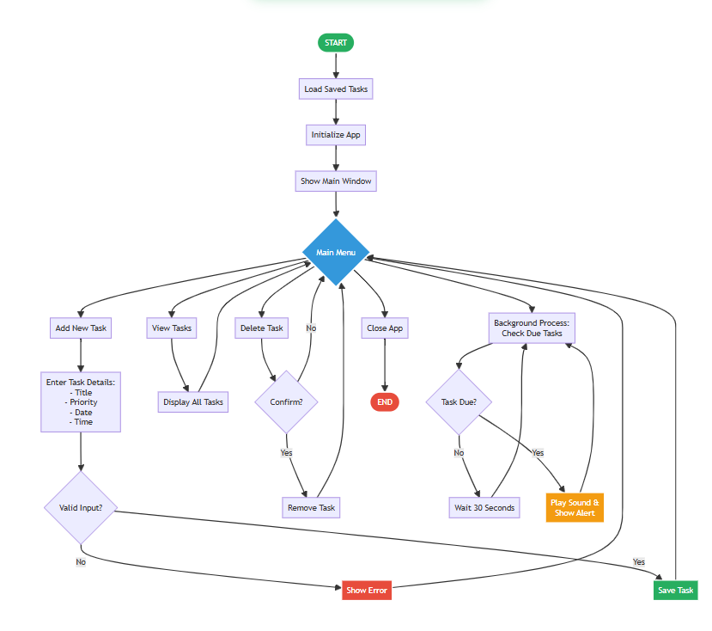
Image 1. Task Reminder Flowchart. Untitled diagram | Mermaid Chart

6. Output
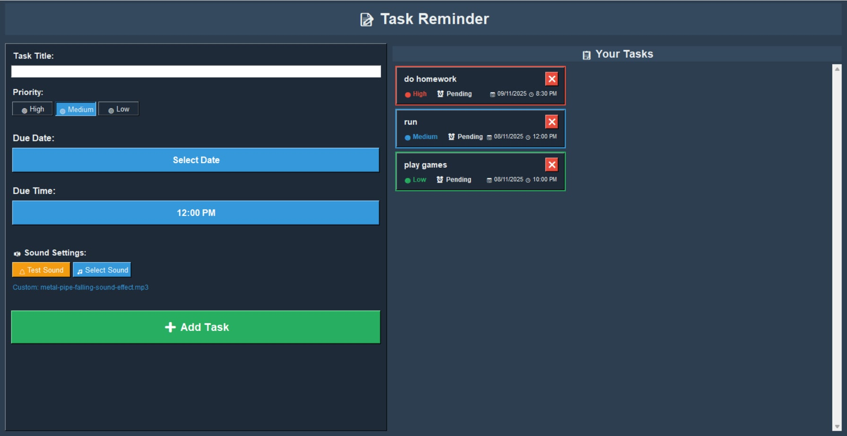

7. Conclusion:
This Task Reminder application stands as a testament to how a fundamental data structure can form the robust core of a practical software solution. By architecting the entire system around a custom Linked List, the project successfully balances educational clarity with a professional-grade implementation. It demonstrates that sophisticated programming techniques—such as background threading, notification systems, and data persistence—can be elegantly built upon and driven by a classic data structure.

This project serves as both a practical productivity tool and a comprehensive learning platform, providing immediate utility while offering a deep, hands-on understanding of linked list operations, memory management, and algorithmic traversal. The careful integration of the linked list with the user interface and system services makes it an excellent case study in data structure application.

The methodologies and patterns demonstrated here, especially the design of a core data structure to support all application features, are directly transferable to commercial software development. This analysis confirms that the application successfully achieves its dual objectives: it is a functional, user-friendly program that also serves as a definitive illustration of a linked list in action—a combination that represents the ideal outcome for a project of this nature.

8. References
References
[1] Python Software Foundation. "Python 3.11 Documentation," Python Official Documentation, 2023.
[2] Pygame Community. "Pygame Mixer Module Documentation," Pygame Official Documentation, 2023.
[3] Matthes, E. "Python Crash Course, 2nd Edition," No Starch Press, 2019.
[4] World Wide Web Consortium. "Web Content Accessibility Guidelines (WCAG) 2.1," W3C Recommendation, 2018.
[5] Reingold, E. M., & Dershowitz, N. "Calendrical Calculations," Cambridge University Press, 2018.
[6] Apple Inc. "Human Interface Guidelines," Apple Developer Documentation, 2023.
[7] Mermaid.js Community. "Mermaid Documentation: Flowchart Syntax," Mermaid Official Documentation, 2023.

